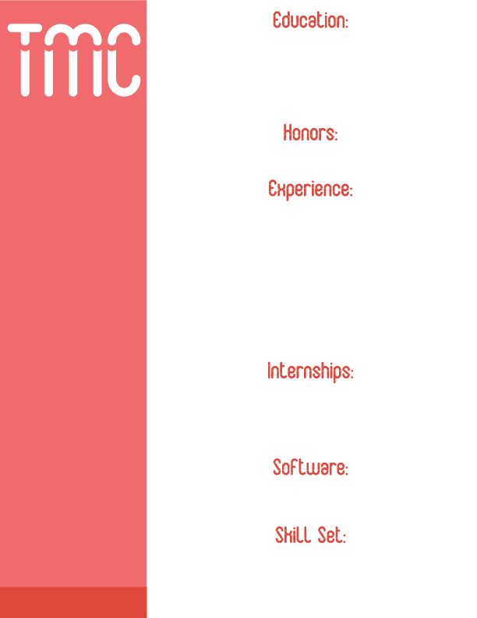

**Façade Interactive:** Project manager and website designer for a

remote website design company. Facilitate tasks and

milestones for developers **(2014-present)**

**Three To Get Ready:** Partner/Co-Founder for a digital media

and design company. Specialize in customized website layout and

design and the enhancement of web content **(2013-present)**

**Green Harvest: The Dave School Production**

Motion capture clean-up and animator and hand key animator

**Orlando, Florida (July-September 2016)**

Compositing, 3D animation, Motion Capture Clean-Up, 3D Modeling

and Sculpting, Figure Drawing, 2D Animation, Digital Painting,

Digital Animation, Drawing, Portrait Painting, Print Making,

Digital Media, Digital Photography, Design for the Web,

Digital Layout and Design, and Business Administration

Nuke, Mocha, Maya, Mari, Modo, ZBrush,

Adobe Creative Suite, Corel Painter, HTML and CSS, Wordpress,

5pm Project Management, Shotgun Studio, and Microsoft Office

**DEOS:** Digital media and graphic design intern with a creative

fashion technology company **New York, New York (Summer 2013)**

**The New York Times:** Internship in multimedia design and

implementation in the department of advertising systems

and operations New York, New York **(Summer 2012)**

**7 of 7 BEST Business and Life Strategies:** Digital design for

an innovative business educational start-up **(Summer 2013-present)**

The National Society of Leadership and Success

Alpha Chi National College Honor Society

**Marist College**

2009-2013 | Poughkeepsie, NY

B.S. Digital Media and B.A. Fine Arts, Minor in Business

Dean’s List Summa Cum Laude 3.892

**The Digital Animation & Visual Effects School**

2015-2016 | Orlando, FL

VFX Production Diploma

Toni Marie Chiarella

**VFX Artist**

tonimarie.chiarella@gmail.com

(203) 598-1640

tonimariechiarella.com

thethreetogetready.com

linkedin.com/in/toni-marie-chiarella